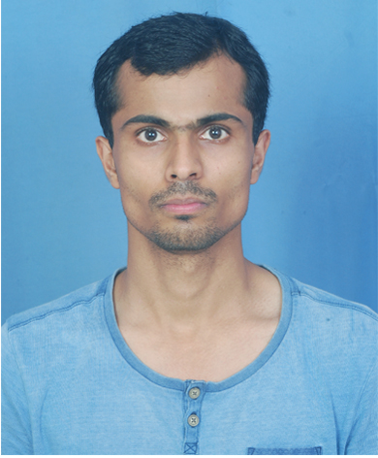

Passport size photograph

Personal Information Form
Name | Anuj Jain | Present Address | Permanent Address
Date of Birth | 10-March-1988 | Plot No-17 UG-4 Sector 10-A Vasundhara Ghaziabad UP 201012 | B-346 Ganga Nagar Meerut UP 250001
Father’s Name | Chandra Prakash Jain | Plot No-17 UG-4 Sector 10-A Vasundhara Ghaziabad UP 201012 | B-346 Ganga Nagar Meerut UP 250001
Sex | Male | Plot No-17 UG-4 Sector 10-A Vasundhara Ghaziabad UP 201012 | B-346 Ganga Nagar Meerut UP 250001
Mobile | 7838076069 | Plot No-17 UG-4 Sector 10-A Vasundhara Ghaziabad UP 201012 | B-346 Ganga Nagar Meerut UP 250001
Email | jaindrive@hotmail.com | Plot No-17 UG-4 Sector 10-A Vasundhara Ghaziabad UP 201012 | B-346 Ganga Nagar Meerut UP 250001
Pancard No. | AMYPJ8994Q
Are you open to work in flexi timings?? Yes/No | Yes
Are you open to work @ Client Location in Delhi NCR?? Yes/no | Yes
Any Reference in Nagarro | No
Any Friend or Relative working in Nagarro. If Yes-Specify Name | No
Open to work Onsite | Yes
Do you have a passport? |  | No | Visa detail if Yes:

Educational Information
Qualification | Degree | Subjects | Marks in Maths | Year | School / College / Institute | Marks (%) & Rank
10th |  | Commerce, Math, English, Hindi, Social Science, Science | 66 | 2004 | SD Inter College Meerut | 54
12th |  | Hindi, English, Math, Account, BO | 66 | 2006 | St. Joseph Inter College Meerut | 51
Graduation | BCA | Computer Science | 88 | 2009 | IIMT Engineering College Meerut | 64
Post Graduation | MCA | Computer Science | 60 | 2013 | Birla Institute of Applied Sciences Bhimtal | 72
Special courses

Experience Details
Company | From | To | Designation | Work Details | Technology
Syscom Corporation Private Limited | Feb-2013 | Aug-2016 | Software Engineering | Automation QA | Core Java, VBScript, MS SQL Server, Selenium and Test Complete
NIIT Technologies | Dec-2016 | Aug-2018 | Senior Test Engineer | Automation QA | Test Complete, VBScript and Python
Sopra Steria | Aug-2018 | Feb-2019 | Module Lead-Testing | Automation QA | Selenium, TestStack white and C#

Technical Rating
Software Proficiency | Self | Software Proficiency | Self
C/C++ |  | .Net
QA / Testing | 3 | ASP.net
ERP /SAP |  | C# | 3
Mainframe |  | Moss
COBOL /DB2 |  | Sharepoint
Natural / Adabas / Assembler |  | Web/ Graphic / Usability
LINUX / PERL / SCM |  | PHP
Java | 3 | IPhone
Core Java / Advanced Java |  | Date Base / SQL / Oracle | 4
Tivoli |  | Any Other (Please mention)

Family Details
Name | Relation | Age | Employed in | Designation
Chandra Prakash Jain | Father | 60 | Self Employed
Aruna Jain | Mother | 61
Deepali Jain | Wife | 26
Priyanshi Jain | Daughter | 4 Month

